Oakton Rowing
Oakton Cougar Crew Booster Club
P.O. Box 3206
Oakton, VA 22124-9206
Oaktoncrew.com

<<Today’s date here>>
Dear ___________________,
I want to express how appreciative we are that you chose to partner with the Oakton High School Crew team.
On behalf of our board of volunteers, coaches, and my fellow rowers, thank you for your gift.
Sincerely,
<<INSERT YOUR NAME HERE>>
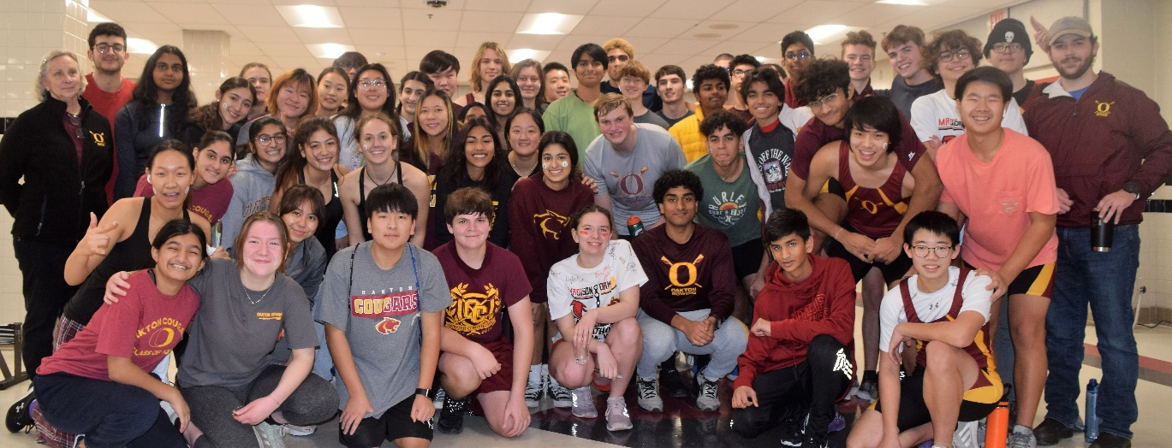
Oakton Crew appreciates your support!

